**AUNet: Attention-guided dense-upsampling networks for breast mass segmentation in whole mammograms**

**Authors :Hui Sun1, Cheng Li1, Boqiang Liu, Hairong Zheng, David Dagan Feng, Shanshan Wang\***

**Attention-guided dense-upsampling network (AUNet)** for accurate breast mass segmentation in whole mammograms directly.

In AUNet, we employ an **asymmetrical encoder-decoder structure and propose an effective upsampling block, attention-guided dense-upsampling block (AU block).**

Especially, the AU block is designed to have three merits.

* it compensates the information loss of bilinear upsampling by dense upsampling.
* it designs a more effective method to fuse high- and low-level features.
* Thirdly, it includes a channel-attention function to highlight rich-information channels.

We evaluated the proposed method on two publicly available datasets, **CBIS-DDSM and INbreast**. Compared to three state-of-the-art fully convolutional networks, AUNet achieved the best performances with an **average Dice similarity coefficient** of **81.8% for CBIS-DDSM and 79.1% for INbreast.**

**AUNet employs an asymmetrical structure – different encoder and decoder blocks – through the implementation of residual connections**

Novel upsampling module, attention-guided dense-upsampling block (AU block), to compensate the **information loss** caused by **bilinear upsampling**, effectively fuse the high- and low-level features, and at the same time, highlight the rich-information channels.

**Preprocessing**All the images along with the masks were first processed to remove the irrelevant background regions (rows and columns have negligible maximum intensities).

Then **resized to 256 x 256**, followed by an **intensity normalization.** Before inputting into the networks, the gray images were changed to RGB images by copying the pixel values to the other two channels.

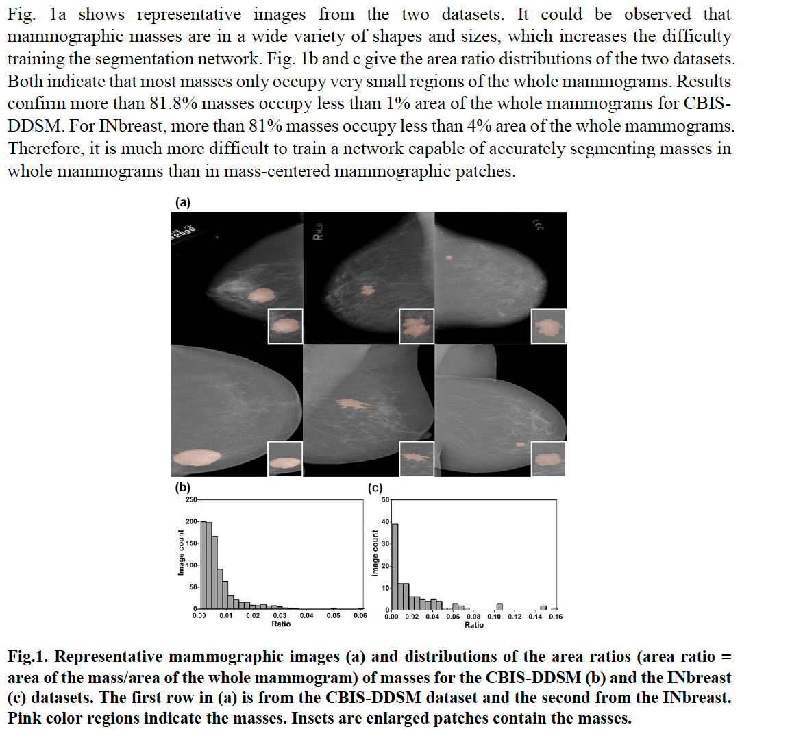

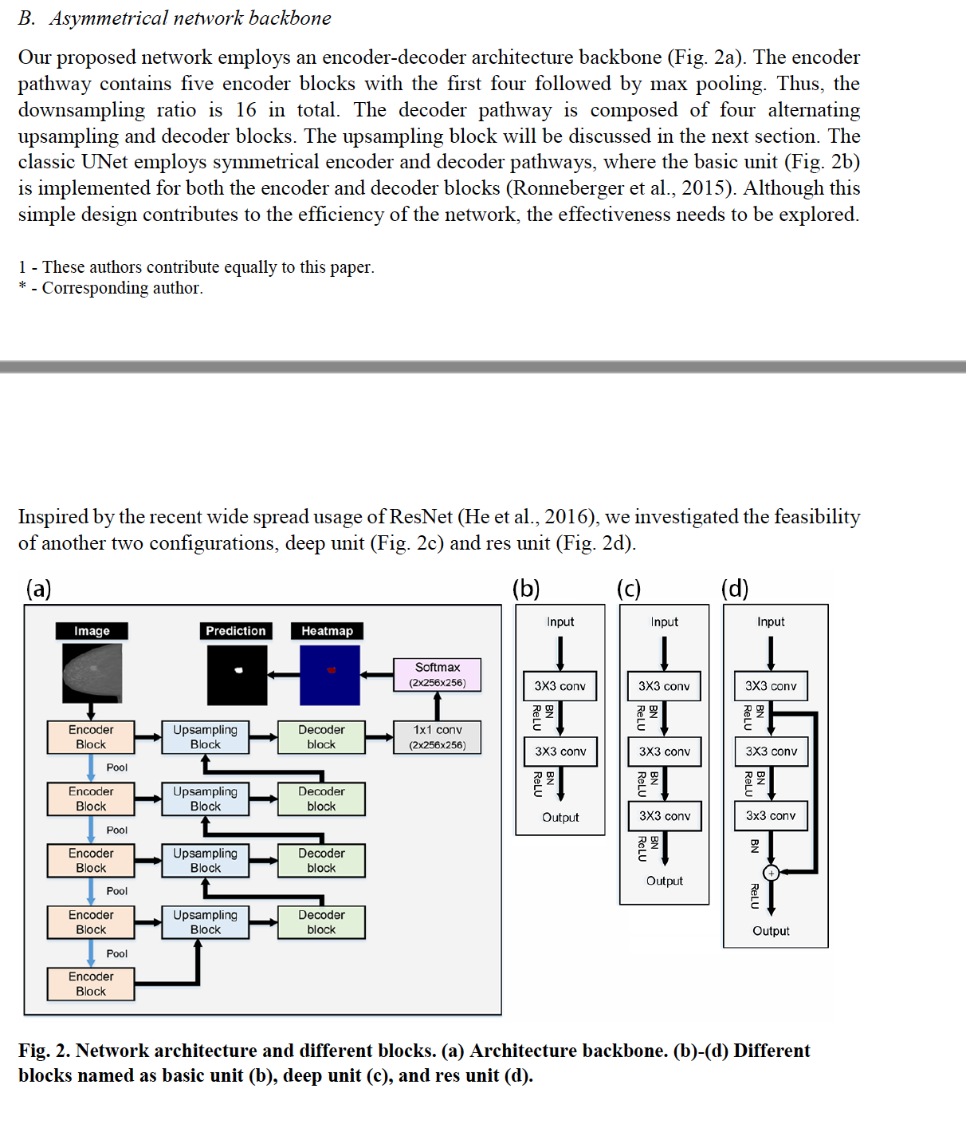

For the three different units, we have the respective outputs as follows:

𝑦𝑏𝑎𝑠𝑖𝑐(𝑥)=𝛿((𝑊𝑏2∗(𝛿(𝑊𝑏1∗𝑥+𝑏𝑏1))+𝑏𝑏2)

𝑦𝑑𝑒𝑒𝑝(𝑥)=𝛿(𝑊𝑑3∗(𝛿((𝑊𝑑2∗(𝛿(𝑊𝑑1∗𝑥+𝑏𝑑1))+𝑏𝑑2))+𝑏𝑑3)

𝑦𝑟𝑒𝑠(𝑥)=𝛿((𝑊𝑟3∗(𝛿((𝑊𝑟2∗(𝛿(𝑊𝑟1∗𝑥+𝑏𝑟1))+𝑏𝑟2))+𝑏𝑟3)+(𝑊𝑟1∗𝑥+𝑏𝑟1))

where y is the respective output of the different units and x is the corresponding input.  refers to the ReLU function. W and b refer to the weights and bias of the different convolution

layers. * is the convolution operation.

